

**INTRODUCTION**

**PROJECT OUTLINE/ OBJECTIVE**

The primary objective of this report is to gain insights into customer behavior through the analysis of purchase history, understand customer satisfaction levels, inform market strategies, and provide guidance for future investments. By scrutinizing this dataset, we aim to obtain a deeper understanding of the competitive market landscape and customer preferences. The dataset encompasses information from 127 restaurants located in four cities across Mexico.

The report will address the following key questions:

**PROBLEM STATEMENT:**

**Question 1.**

What can you learn from the highest rated restaurants? Do consumer preferences have an effect on ratings.

**Question 2.**

What are the consumer demographics? Does this indicate a bias in the data sample?

**Question 3.**

Are there any demand and supply gaps that you can exploit in the market?

**Question 4.**

If you were to invest in a restaurant, which characteristics would you be looking for?

**SKILLS DEMONSTRATED:**

* Power Query
* Data Modeling
* Data Cleaning
* Data Visualization

**DATA SOURCING:**

The Dataset was provided by digitaleydrive Link to Dataset

<https://drive.google.com/file/d/1c1HKM8UTqwWOgexRLOtEJuxjBiA2N6xf/view?usp=drive_link>

**DATA TRANSFORMATION:**

Having downloaded the data into Power Query Editor for cleaning and transformation after looking over and extracting the data from the 'Restaurant_Ratings.zip' file, which contains five CSV files (Restaurants, Restaurant cuisines, Ratings, Consumers, and Consumers preference). During this procedure, I used the first row as the header for some datasets and substituted 0 for null values. Following the data cleaning process, we noticed that a few datasets had one or two connections. These connections were Restaurant ID and Consumer ID, which were used as the main key to merge all of the datasets as you can see below.

**DATA MODELING:**

After completing the data conversion phase, I proceeded to data modeling and carefully evaluated relationships. I cleaned up the data with Power Query and then exported it into Power BI, where relationships were built without any problems. However, I conducted a comprehensive review to ensure that all of the links between different data sets were accurate and that there were no errors in them.

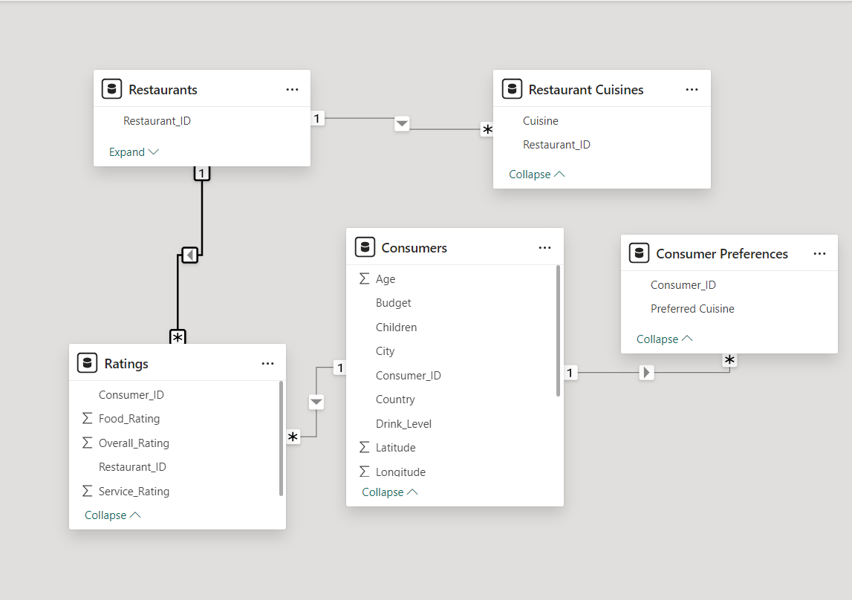

**ANALYSIS AND VISUALIZATION**

.

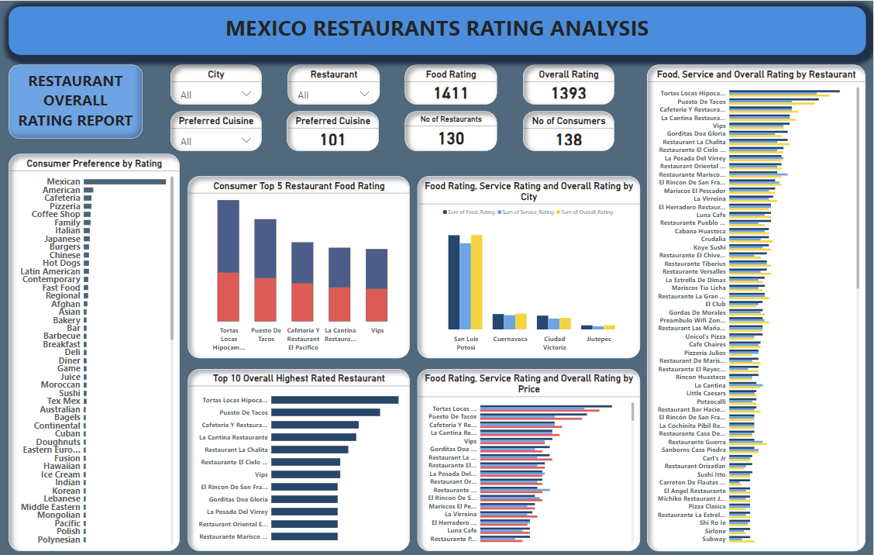

Overall Rankings by Restaurant: "Tortas Locas Hipocampo" has the highest rating of any restaurant at 48, then comes "Puesto De Tacos" at 41 then "Cafeteria Y Restaurante El Pacifico" at 33. This shows that "Tortas Locas Hipocampo" is doing outstandingly when it comes to client contentment. A restaurant established in the state of Tortas Locas Hipocampo cited in the city of San Luis Petosi would drive in locals which the fore aim of trying out medium priced dishes and cuisine especially if its environs are closed and has schools all around it. Consumers selected Mexican Cuisine is the most popular and preferred cuisine, selected by 97 consumers, followed by American (11), and then cafeteria and pizza (9 each). This suggests a significant consumer preference for regional food, which may be the reason for the good reviews of Mexican eateries like "Tortas Locas Hipocampo."

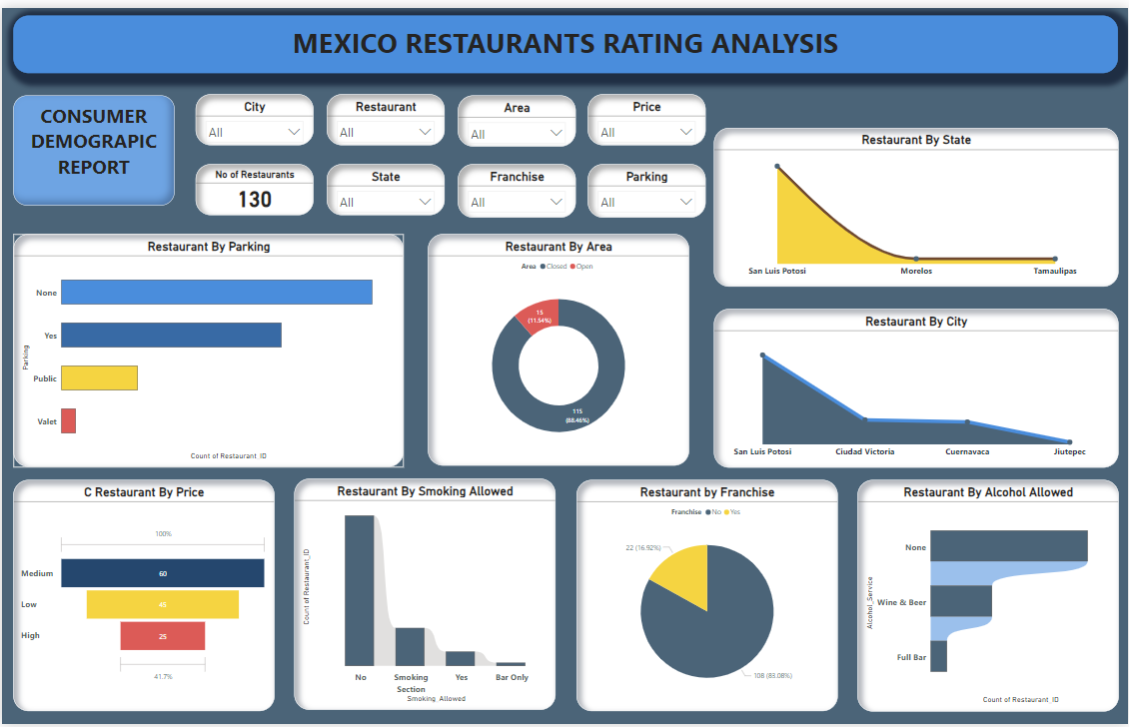

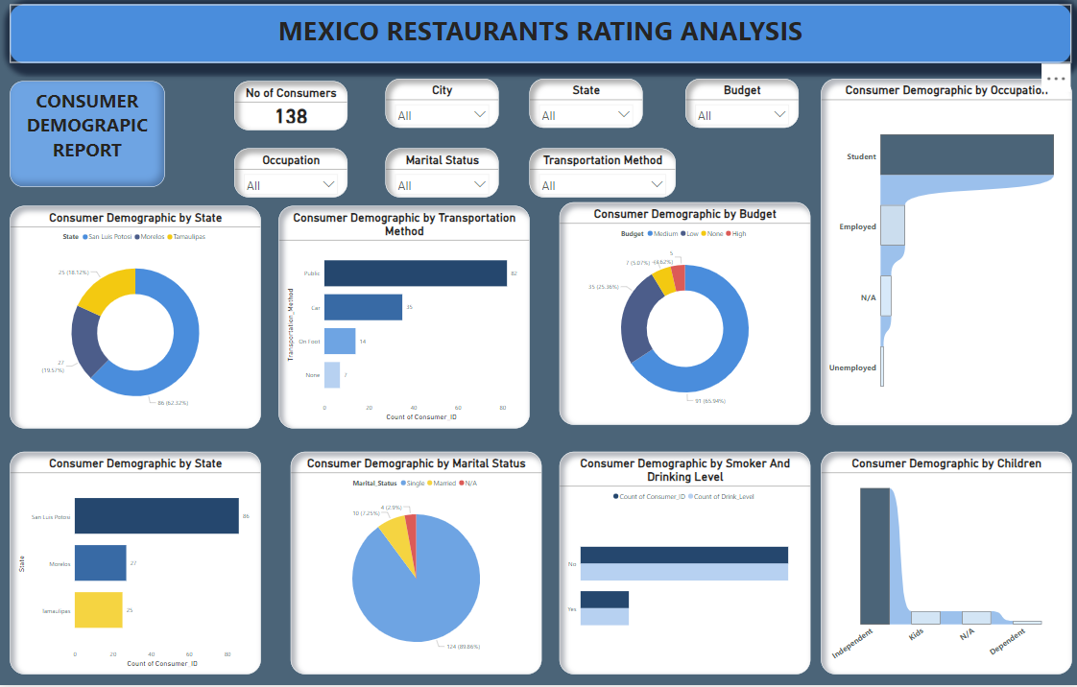

Age, Employment, and Marital Status-Based Restaurant Food Ratings:

The table displays a range of patrons, the majority of whom are single and learners. This could suggest a bias in favor of younger, single people in the collection of data, that may restrict the applicability of the findings to other demographic groups. Consumers with children ar relatively higher than the singles. Als a very great large number of consumers do no not associate in the act of drinking and smoking.

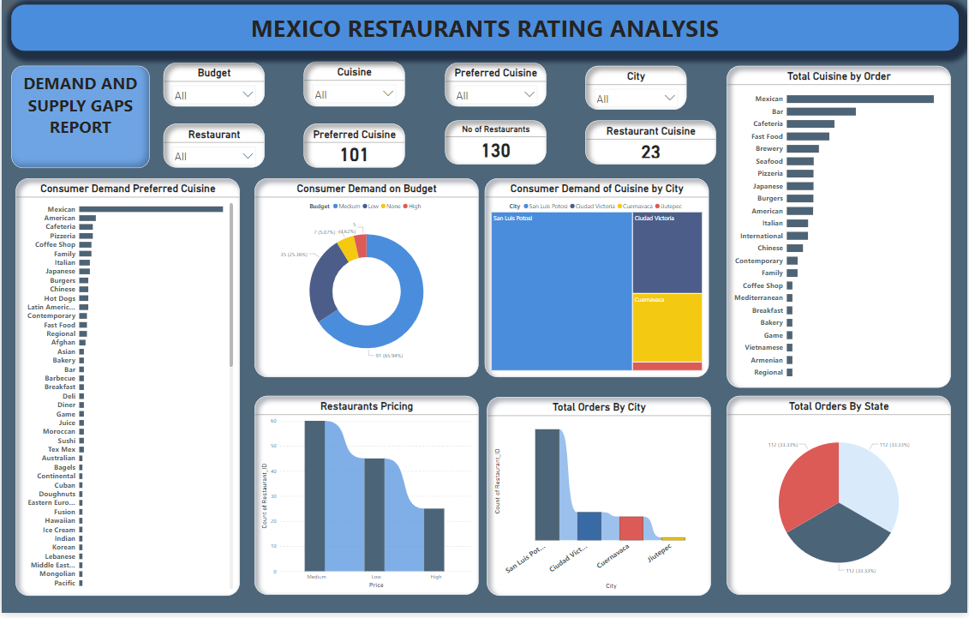

Service Rating by Alcohol Service: As seen on the dashboard, more than 60% of restaurants do not provide alcoholic beverages, earning a superior service rating. This reveals a high market preference for restaurants without alcohol service choices, followed by 30% for restaurants with wine and beer service.

Count of Service Ratings by Smoking Allowed: The majority of restaurants do not allow smoking, which is consistent with a general trend towards non-smoking surroundings. This might suggest a desire or a legislative environment that favors non-smoking venues.

Mexican cuisine is highly preferred across all budget categories, particularly in the medium level. This shows a strong desire for Mexican food. Other cuisines, such as American, Cafeteria, and Pizzeria, are also popular, particularly in the medium-priced category.

The majority of service evaluations come from locations where smoking is prohibited, which may distort perceptions of what customers desire in terms of smoking

The no alcohol policy and no smoking policy that this new restaurant would pride on would drive locals in as the data analysis shows a low percentage patronage of alcohol and cigarettes. The interior and exterior designs of this restaurant would be focused on single and independent individuals who mostly have medium budget plans for their food patronage. An acute parking lot or better no parking space would influence the free flow and convenience of the locals. Restaurants with "Full Bar" (34.29%) and "Wine and Beer" (33.8%) have the highest average overall scores according to alcohol service. The lowest ratings (31.9%) are given to restaurants that do not provide alcohol.

I will love to hear any feedback in the comments below.

THANK YOU!!